Prerequisite:
Installation of Adempiere is already completed. If not please install Adempiere by following the steps in Adempiere installation document.
Steps
- Run RUN_adempiere.bat from the command prompt which is c:\Adempiere you see the following screen.
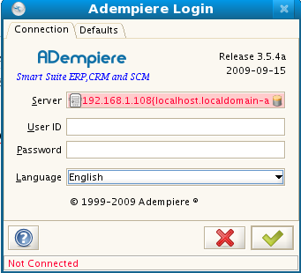
2. Enter the user id as System and password as System, select language as English, then click on
3. Then it takes you to the following screen
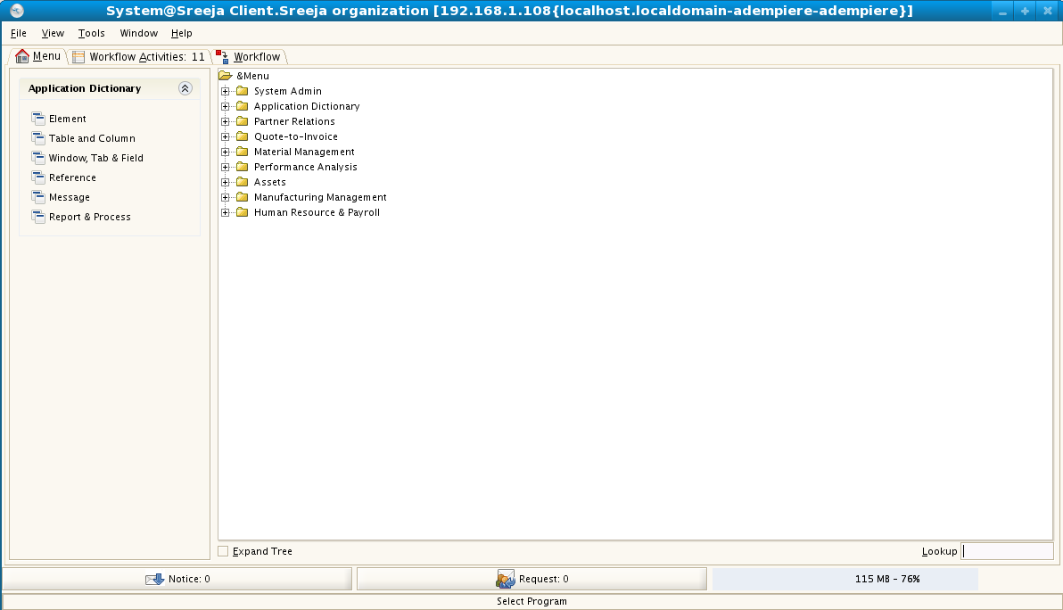
- Click the role as SystemAdministator and there will be default client( System ), which is part of installation. Then click on OK button
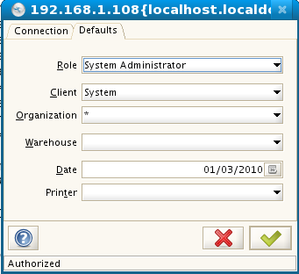
- In any Adempiere configuration, new client needs to be setup
Note: Adempiere allows multiple clients(for examples Customers to walkingtree ) to use same installation of Adempiere. In Sirija's case, there is only one client so we need to setup one Sirija client.
- On center screen, click on “System Admin”, then click on “client rules” and then click on “Initial client setup”
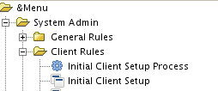
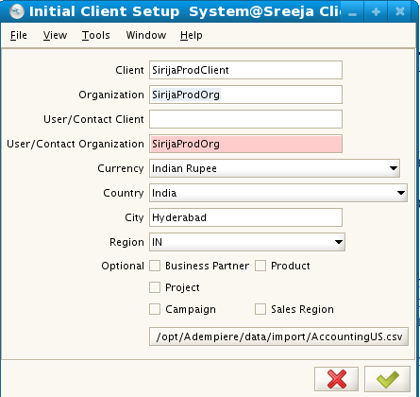
- It takes us to the following screen

- Enter client name as SirijaProdClient and organization name as SirijaProdOrg, no need to enter User/Contact Client. Enter User/Contact organization as SirijaProdOrg.
- Select the currency as Indian rupee, country india and city Hyderabad. Do not give importance to region, I see it is more of USA based installation.
- In optional bar, do not select any thing, if we select that it creates default setup for those selected items.
- Here we are left with an important step to which is “loading accounting values”. In Sirija's case as we are not giving accounting module, this is not important step. So the select AccountingUS.xls which is in data/import of Adempiere home directory and import that file.
- Then OK button will be enabled, Click on to complete the client creation.

Note: This step is to create different set of 5 basic account types (Asset, Liability, Revenue, Expense, Capital ), file will contain the list of accounts for each for different for each account type. Preparation of the file which contains the data itself is a another task and there is separate executable which can generate these files. How to generate this is file not in the scope of the present document.

- After creation of the client we see the following screen. If we closely observe the below screen it created two roles one is SirijaProdClient Admin and another is Sirija Prod Client User.
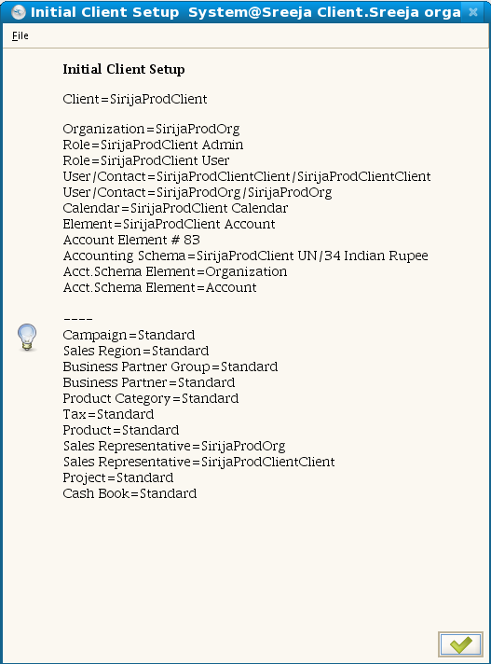

- Then log out of the system and re log in with System/System user name and password. Then you see two new roles, they are for the client we setup then login with “SirijaProdClient Admin” role to continue with the next steps. It in default takes standard warehouse and then click on 'OK'. Next steps allows setup the user roles for the client

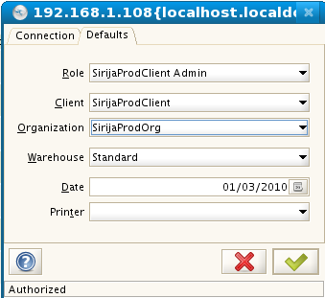

- On center screen, click on “System Admin”, then click on “General rules ” then click on “Security” and then click on User, Here we see the set of users

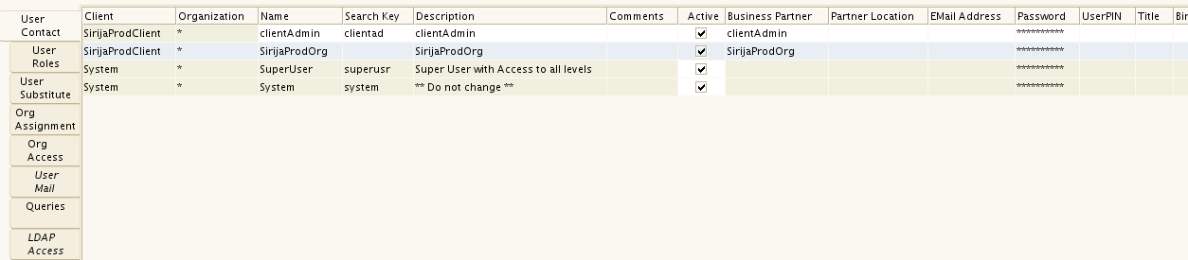

- On center screen, click on “System Admin”, then click on “General rules ” then click on “Security” and then click on Role, Here we see the roles for each user, here we can configure the the functionality based on the user.
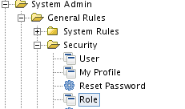

- Then we see the list roles for each user, on the left side each tab has unique set of task to accomplish. We will go through required tabs to set up access to the users. As “SirijaProdClient” is highlighted, when we click on next tabs, data associated to “SirijaProdClient” will be displayed and allowed to modify.
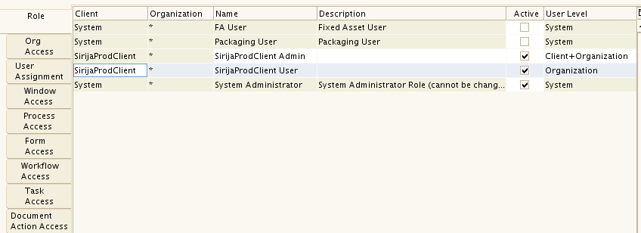

- There is nothing to change in “Org access” as Sirija has only one organization.
- Click on User Assignment tab. It shows set of users that can access this role. Our focus is on SirijaProdOrg ans this user is in map with users shown in step 11
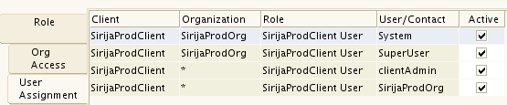

- Click on Window Access tab. It shows all the list of windows that can be accessed by the role name we selected “SirijaProd client User”.

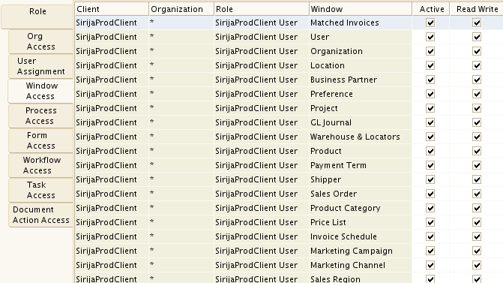
It shows many windows as active( 5th coulmn, But for Sirija requirement we don't need all them). We need product, business partner, material receipt, product attribute windows so for remaining windows un check the active flag. After un checking the not required windows see the list of windows. In case of if you want the user to change his information, then keep “My Profile” window, otherwise un check the active flag.
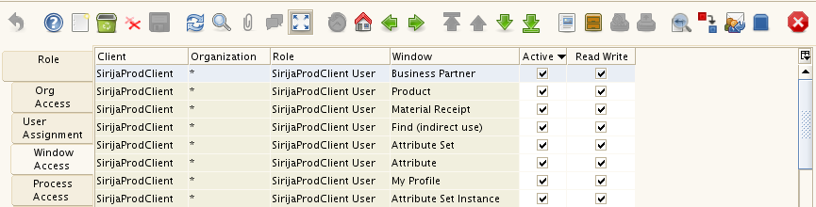
- We do not need any processes as per Sirija requirement. So uncheck all the active processes. There are 270 processes and unchecking all of them one after another is pain ful thing. Need to find a way out for that.
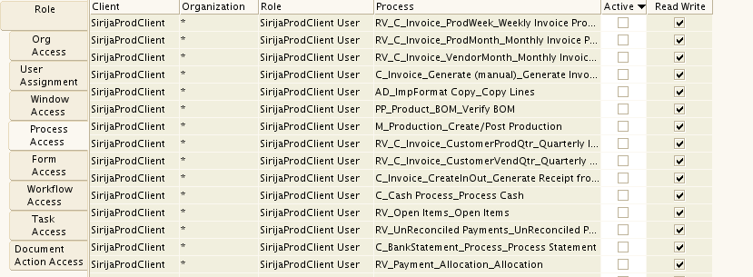
- We do not need any forms as per Sirija requirements first cut. So uncheck all the active forms
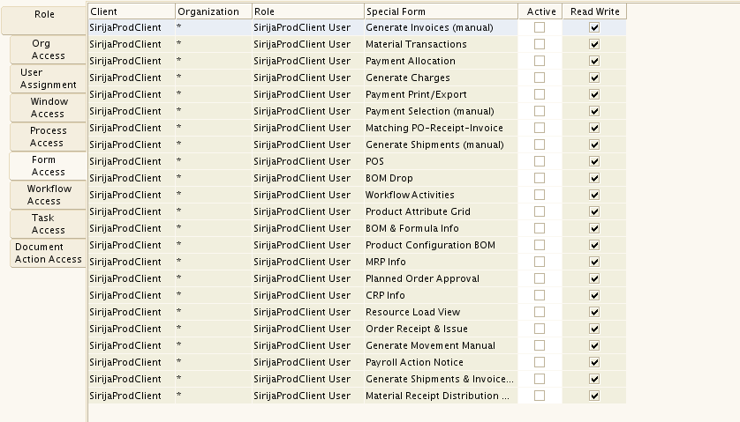

- We do not need any work flows for user as per Sirija requirement, so un check all of them
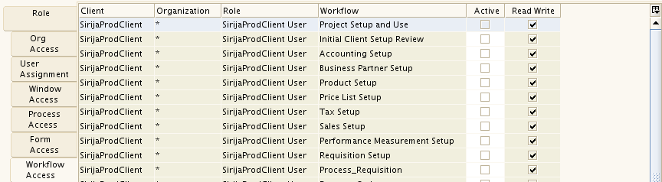

- There are no tasks for the this role so nothing to do.
- In Document action access, Adempiere has 555 actions, so uncheck all of them.
- Then repeat the step 11, now we want to change the password for SirijaProdOrg, as we don't know the original password. I changed password to adempiere, give the password as you like but remember the password. Then save the changes, by clicking save button on top of the window.
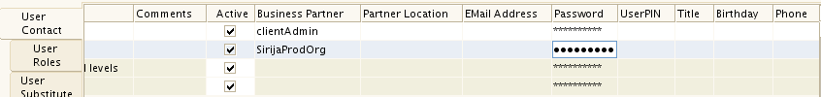

- Then logout and login as SirijaProdOrg. Remember username and password are case sensitive.

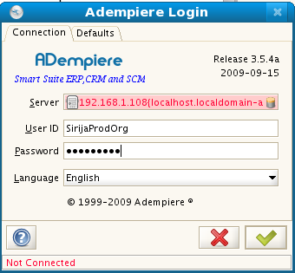
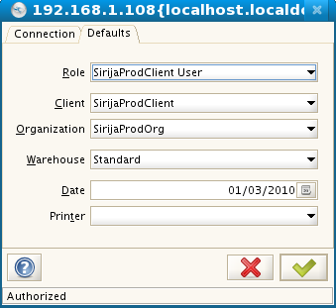
- Then you see will only the required entities, that are selected for the user.
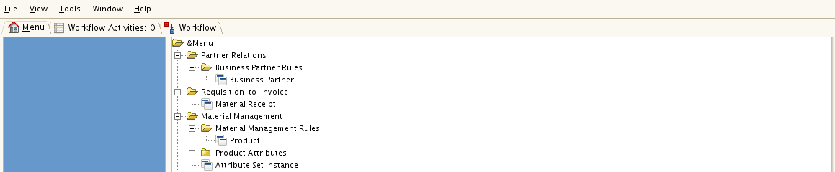

- Right click on the BusinessPartner Button and select to “add bar”, to create the short cut for the required things.

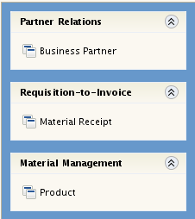
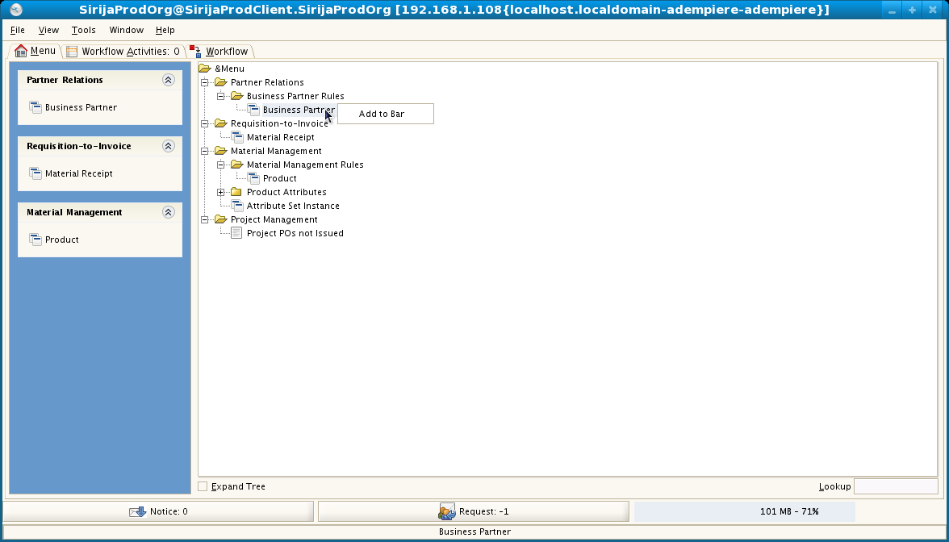
Add the required entities to the menu, they can be used as short cuts, after adding all the items, screen left side looks like as follows. Those links can be directly used to run the operations.

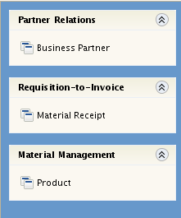

- From steps 16 to 21, we configured that windows that are required by the user. Now the next set of steps, will guide you to configure the content in the windows based on the user requirement. Now logout and login as with System/System user name/password. Select the role as System Adminstartion and select the client as SirijaProdClient and login. You will get the following screen

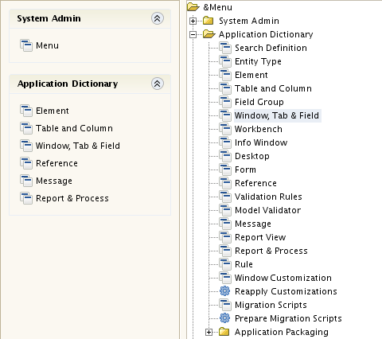

- Click on the Window, Tab & Field column and you see the following window. This window look up window for windows in adempiere
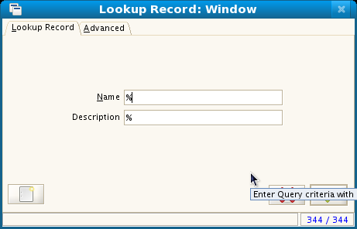

- We want to see the product window, so enter name as product and see the results
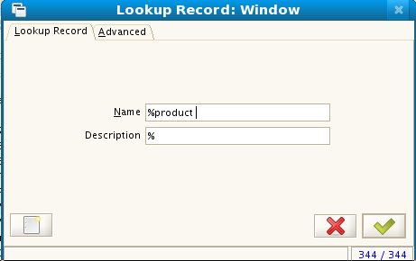
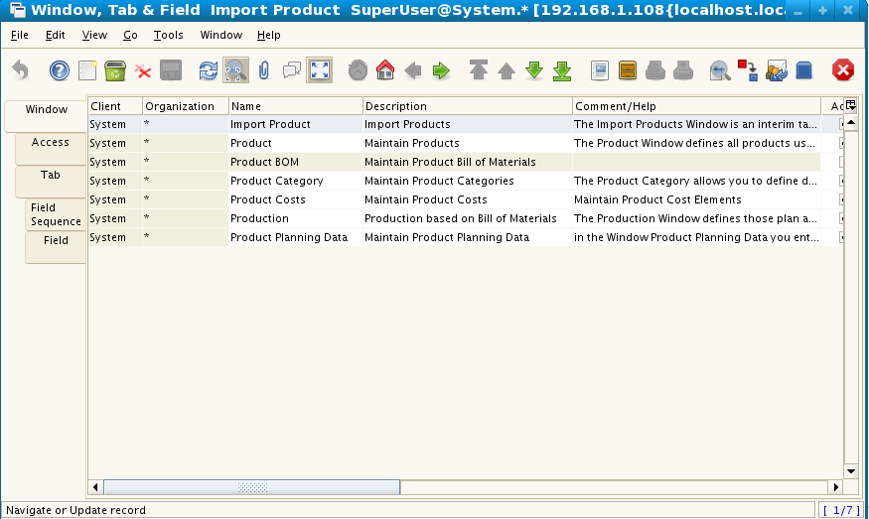
In the grid table that came, we are interested in “Maintain Products” , select Maintain prodcuts row and click on “Tab” tab to see the list of tabs for that main products window.

- Then it shows the following list of tabs for the maintain product, out of those tabs we need only, out of those tabs we need only Product, Replenish, Price, Located at tabs( Fourth coulmn int the table grid ), so un check the Active flag for the remaining tabs.
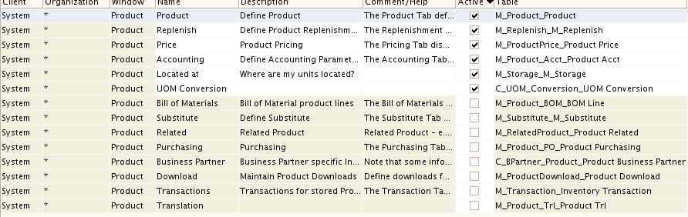
So only those required tabs will be displayed in the window, when user logged in.

  - Now in each tab, we need to analyze the fields in each tab. So select product row( first row ) in grid tab, and click on field sequence, So it displays all the fields in that product tab.
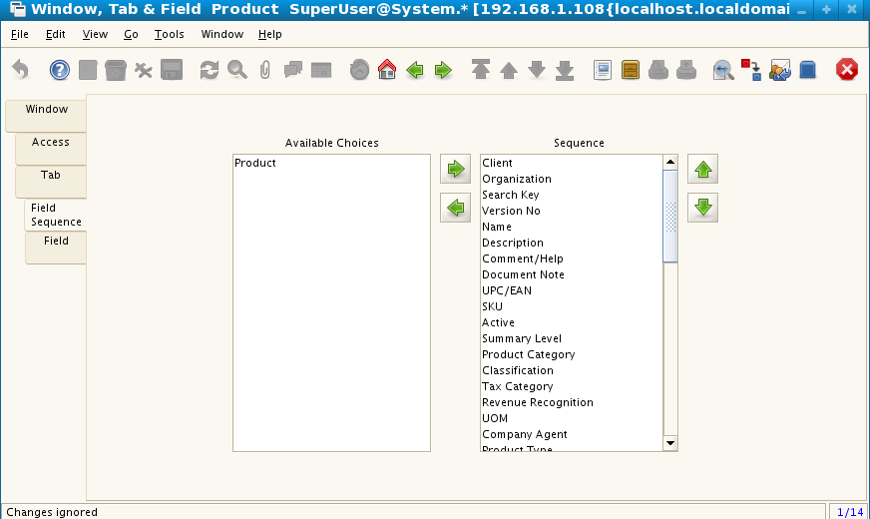
Fields on the right hand side of the window( Heading sequence ) is list of fields that will be displayed in product tab. We don't need all the fields, so move the extra fields into left window.

We decided that we need only 6 fields out of that entire list.

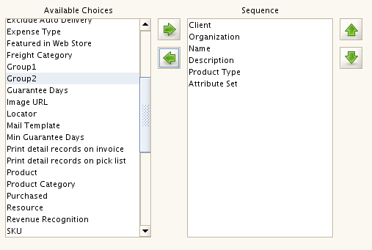
If you want to change the order move up or down by selecting particular field.

- Now click on field tab, which is the last tab. For the items that were selected in previous window this contains more information like the relation between different entities. This table contains many more columns, like displaying the two fields in same line, read only, only field, only header etc, mark them based on requirement. If we want to change label for a field, modify the “name” column.

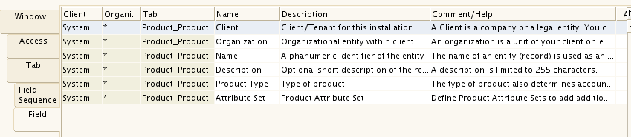
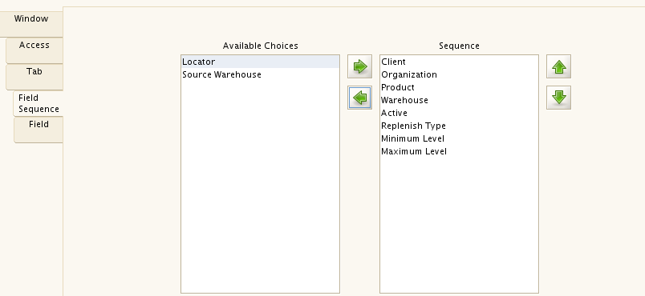
- Now select the replenish column in the image in step 29 and repeat the above steps. Click on field tab make required changes as per the need like having two fields on same like. Make some fields read only
- For price list tab see the fields I selected. Change the name of List Price and Standard price suitable to Sirija's need.

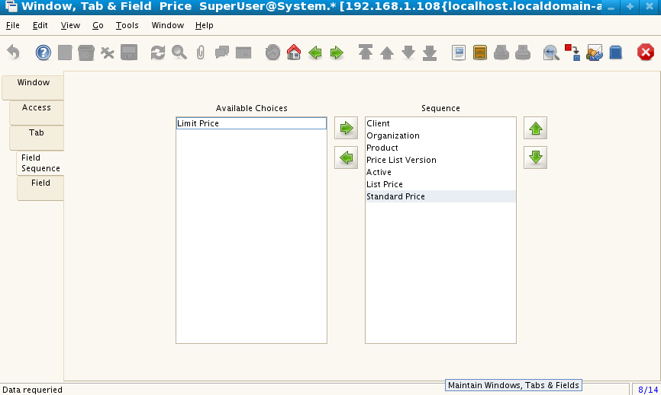
- For the location tab,see the list below
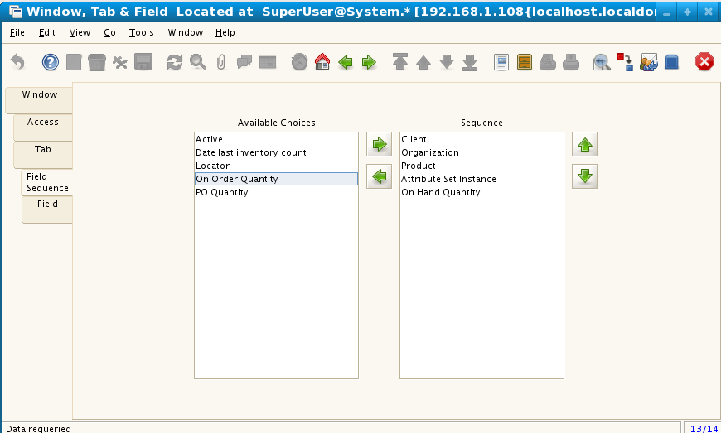

- Now logout and login as SirijaProdOrg and try to create the product, you see the following list tabs. It has the four tabs as we configured and each tab will have the fields we selected. With this configuration of product is completed. Now we move on to the steps of configuring business partner and material reciept.

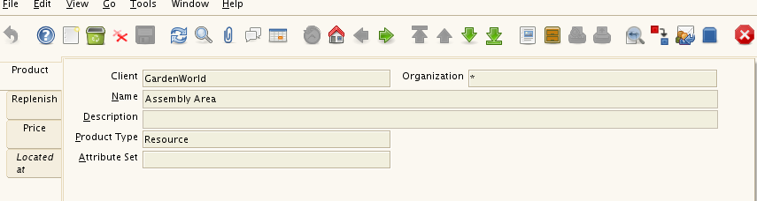
- Now logout and login as System/System and select the SirijaProdClient as the client. Now Search for business partner.
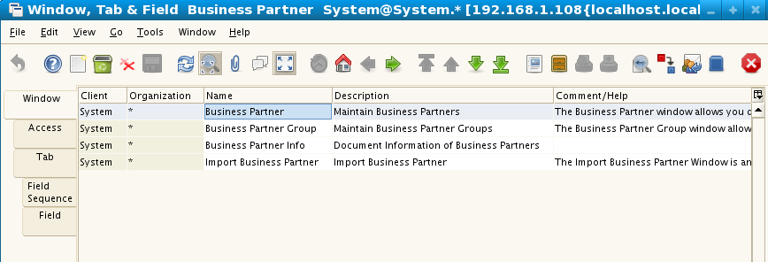
- Select the business partner and click on tab “Tab”. Now we are interetsed only Business Partner and location. So uncheck the remaining tabs.

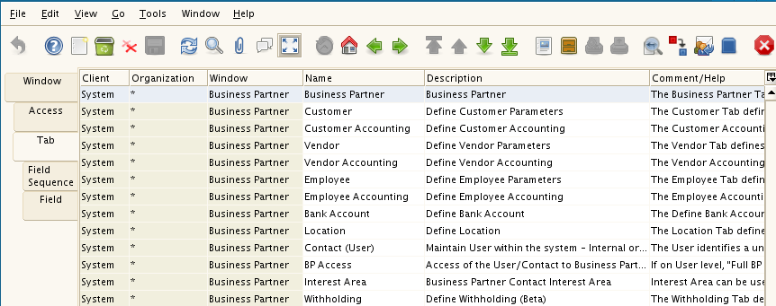
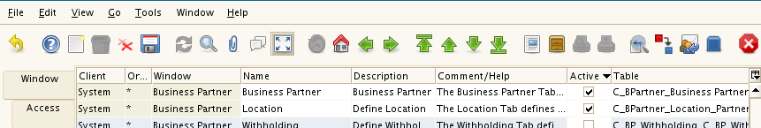

- On business partner I selected the required fields, by going to field sequence tab.
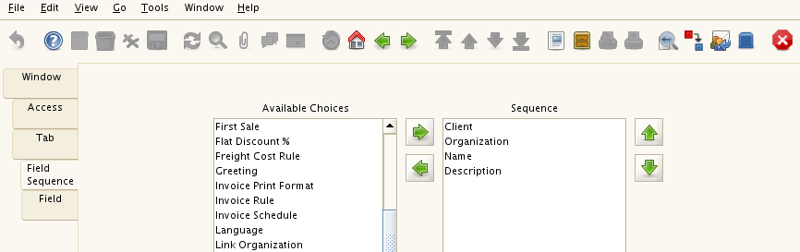
- On location, selected the fields that are required for business partner.
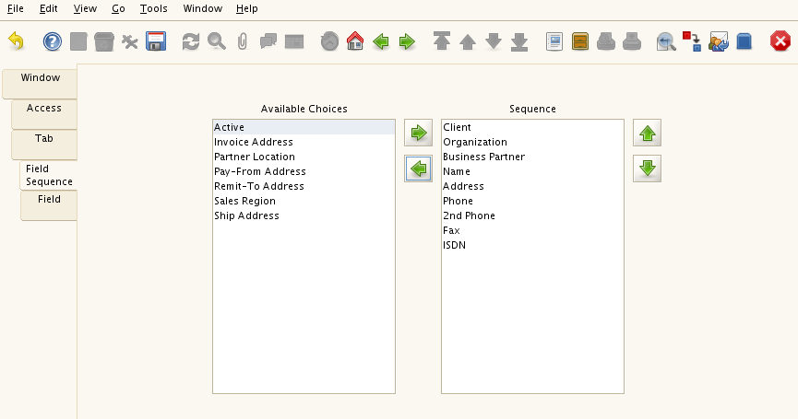
After this step, we are done with configuring the business partner for sirija, now let us configure material receipt, before we go and login as normal user to create business partner and material receipt.

- Search for material receipt window( Similar to the step 28). Select material reciept.
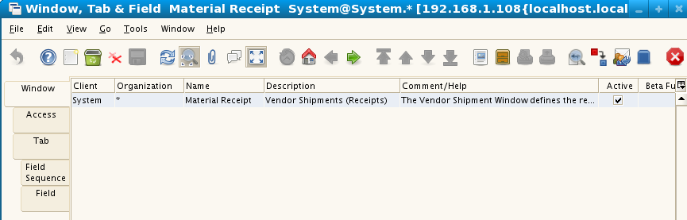
- Search for material receipt window( Similar to the step 28). Select material reciept and click tab “Tab”, we need only receipt and receipt line, so un check the remaining items

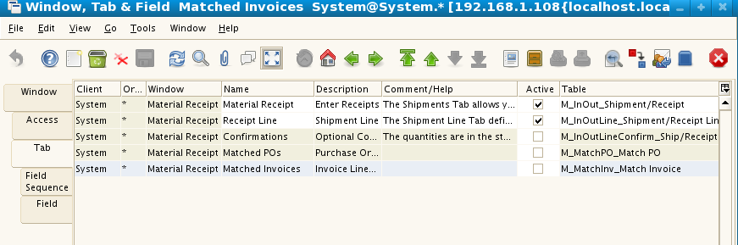
- Select Material receipt column and click on FeildSequence tab and move the not required fields into the left box.

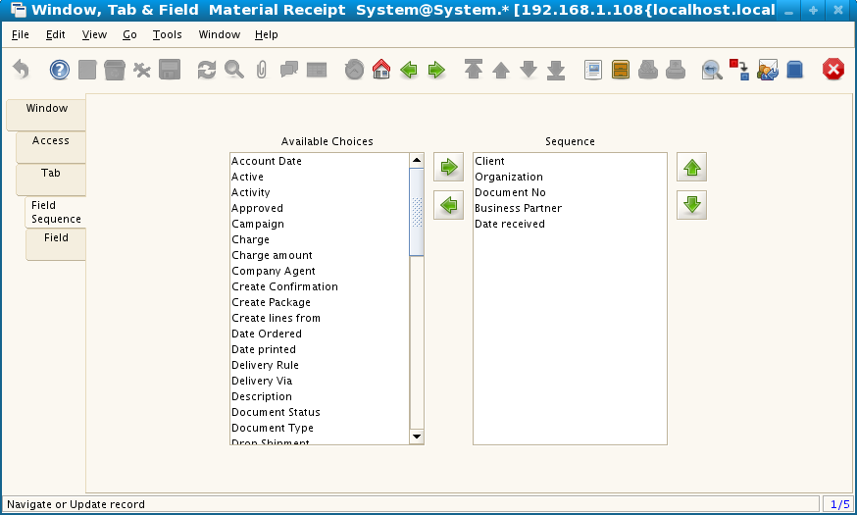

- Search for material receipt window( Similar to the step 28). Select material reciept.
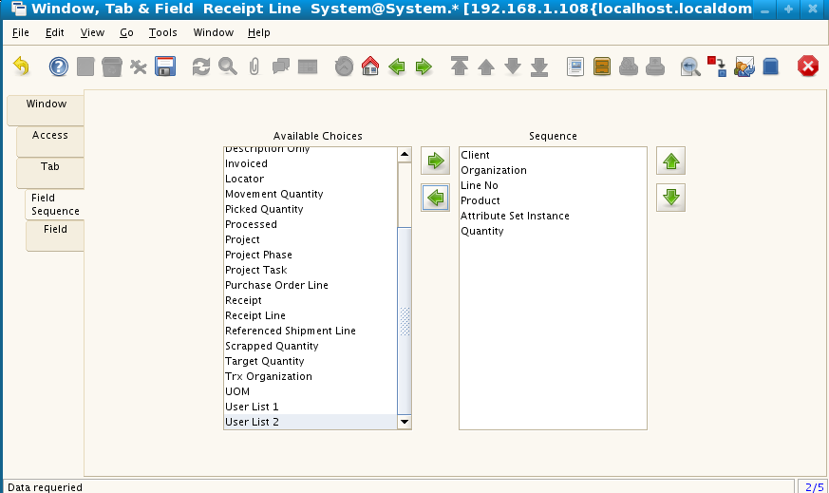
With this is setup of material receipt is also completed.

- Now log off and login as normal user ( SirijaProdOrg ). Now we need to create attrbutes and then prepare attribute set with them. Requirement is Sirija to store batch id, Date of expiry and date of manufacture for each product that is received through material reciept. So create batch id,date of expiry and date of manufacture as attributes and group them in set.

To achieve this click on Materail management, product attributes and click on attrbute

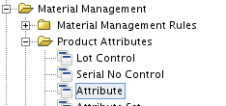

- Create the attributes
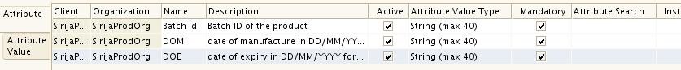
- Now first create set and made this mandatory type is “always manadatory” So where ever this attribute is added instance of this attribute should be mandate.

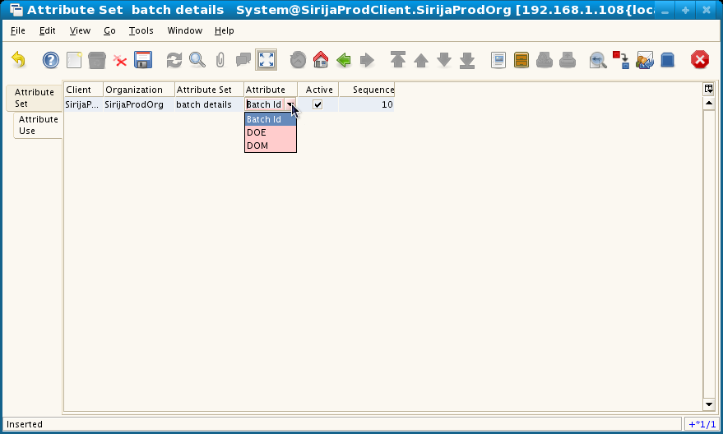
- Now click on “attribute Use” tab to add the attributes that are defined in step 44.
Add all the three attributes one after another and see the data. This is one time effort, just after the installation of the system.
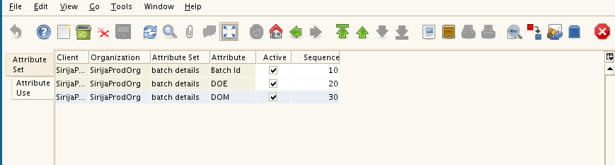

    - Now the system is ready to use and now user can create business partner, product and material receipt in the system.

- Create the attributes

